PRODUCT DETAILS

**Ladies Guess Watch W1156L5**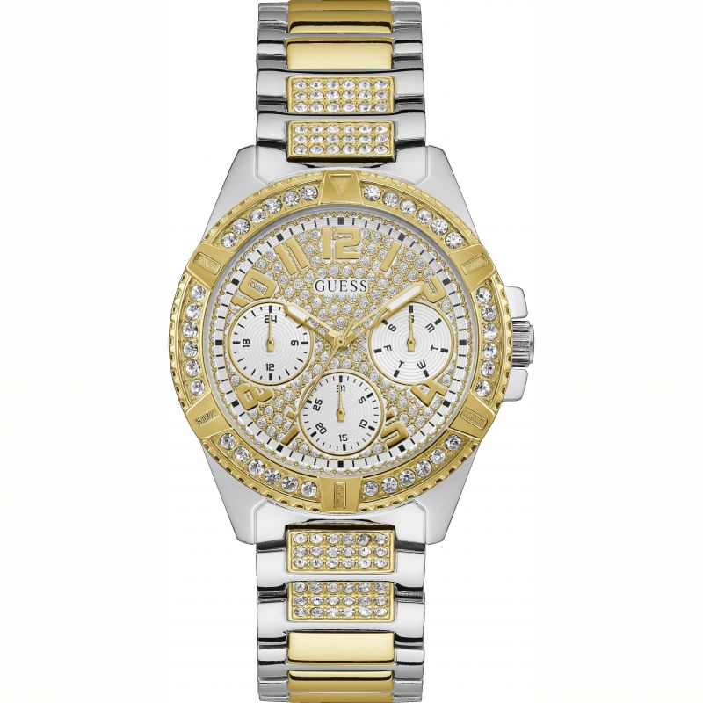

**£209.00**

**Specifications**

**Brand**: Guess

**Analogue/Digital**: Analogue

**Case depth approx**.: 12.10mm

**Primary** **Material**: Stainless Steel

**Case** **Shape**: Circle

**Case width approx**.: 40.00mm

**Clasp type**: Fold-over Deployment

**Dial Colour**: Silver

**Multiple Time Zones Display**: None

**Gender**: Ladies

**Glass**: Mineral

**Movement**: Quartz

**Strap colour**: Two tone

**Strap Type**: Metal Bracelet

**Water** Resistance: 30 metres

**BARCODE**: 091661504099

**Guarantee**: 2 years